Using IT support need to create a Bot with our logins

**Step 1:**

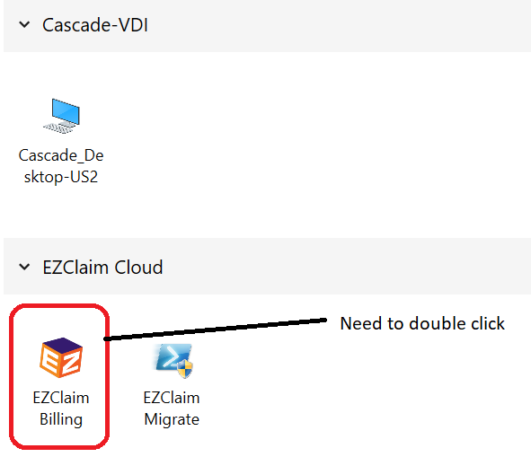

**Step 2:**

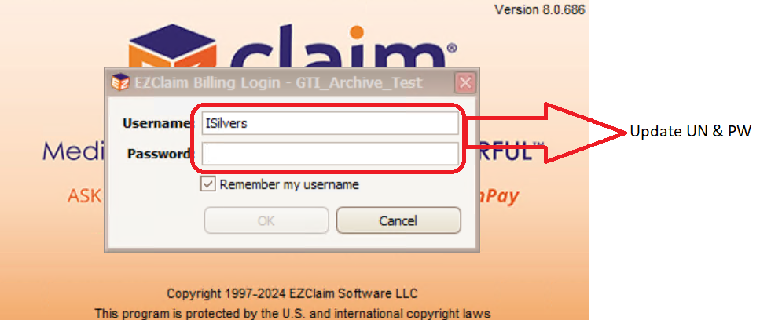

**Step 3:**

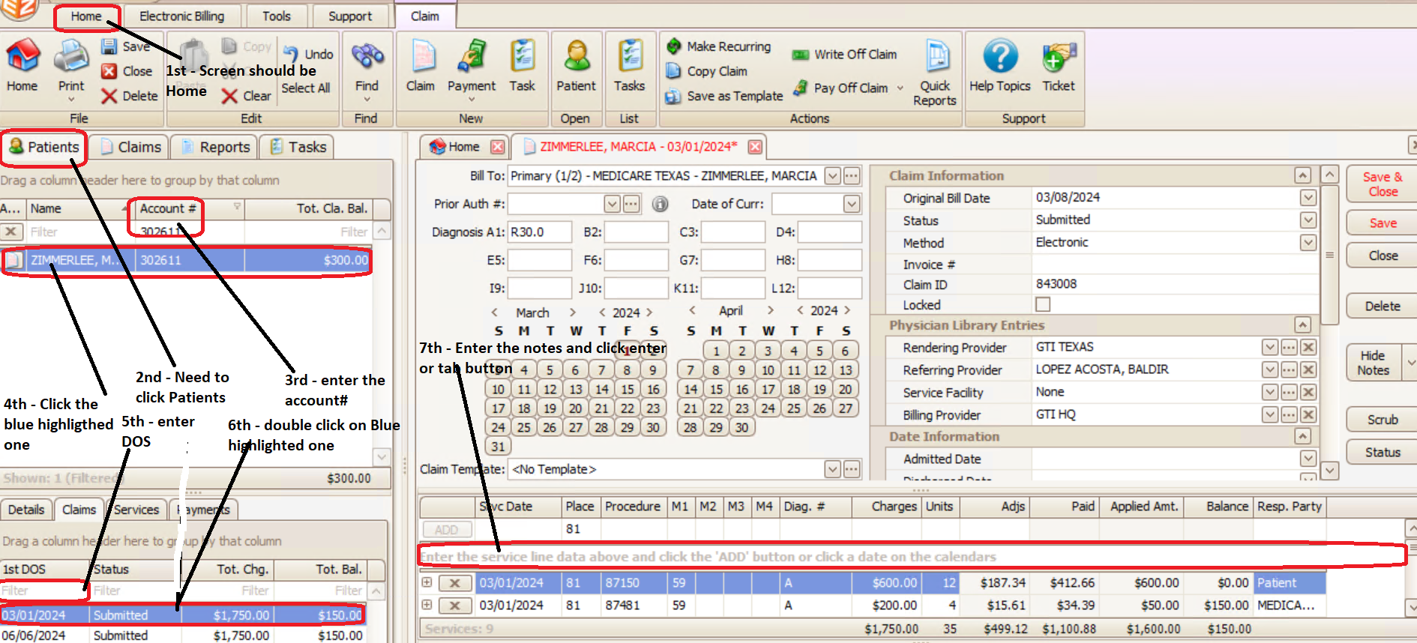

**ONCE NOTES IS POSTED – NEED TO CLICK SAVE**